VILLA BERGZAUBER HOTEL & EVENTS

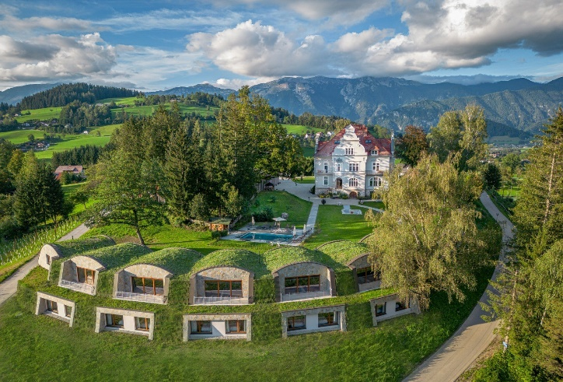

Location: | Roßleithen, Austria  Holiday region Pyhrn-Priel in southern Upper Austria  Airport Linz - 79 km  Airport Vienna – 177 km  Abtei Admont – 34 km  Großer Priel - 23 km  Roßleithen city center – 0,3 km
Address: | Roßleithen 31, 4575 Roßleithen
Activities in Roßleithen: | Hiking and cycling  Ski region Hinterstoder: skiing  18-hole golf course Windschgarsten  Horse riding  National park Kalkalpen
Property description: | On the small hill with the breathtaking panoramic view in all directions,  wonderful mountain scenery, panoramic views of the valley  January 2015 - takeover by the current owner couple  2015-2016 - Art Nouveau villa (built in 1900) was completely renovated and converted into a modern house
Areas: | 3 ha large, park-like land plot  Total land area: ca. 26 500 m²  Plots-Nr. 838/1, 842/1, 842/15, 842/16, 842/17, 842/19, 842/4, 842/5  Villa: BGF 1.712 m²  5 Apartments /Earth houses: BGF 52,5 m² x 5 = 262,5 m²  5 Apartments /Earth houses: BGF 106,8 m² x 5 = 534 m²  Event hall: BGF 551 m²  Total: BGF 3.060 m²
Land use plan: | Tourism operation  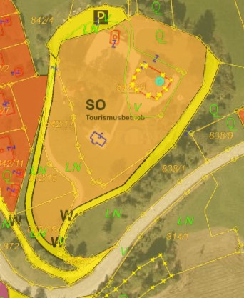

Hotel fact sheet:

Hotel category and guest profile | Hotel & Events  Leisure guests, nature lovers and active,  Seminars, weddings, product presentations, company parties and other events
Logis  (Main house and  earth houses) | Main house  13 rooms & suites in the villa  Earth houses  15 rooms  5 earth houses incl. DAN-kitchen for 2 guests (also fof 4 guests possible) | breakfast and dinner can be booked extra  5 earth houses incl. DAN-kitchen for 4 guests with 2 separate bedrooms and 2 bathrooms/WC | breakfast and dinner can be booked extra  Total: 23 Keys / 86 beds
Seminar and Events | Ballroom for 200 guests  Flexible capacities  Shared lounge
F&B | Restaurant & Bar  Terrace  Meals: BB  A la carte and banquet offer
Wellness | Heated outdoor-pool with salt water  Sauna
Parking | Ample parking
Team | 6 employees mainly full-time
Potential for extension | Since the land plot has a dedication as a tourism operation, there is potential for expansion. An extension of the existing number of guest rooms can only be approved upon submission of a concrete project.

Purchase pice: EUR 10.500.000

Photos:

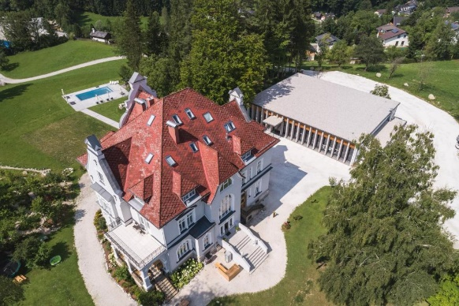 | 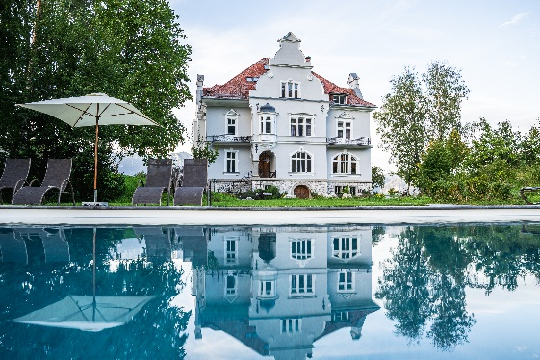
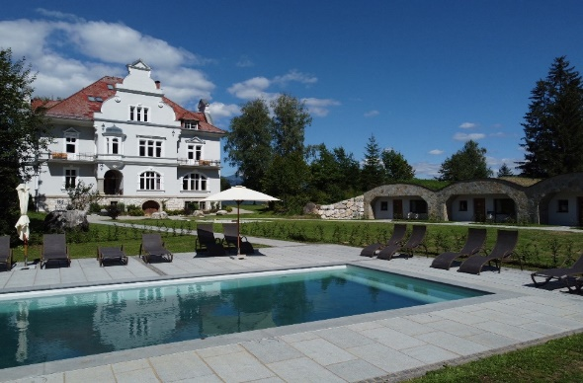 | 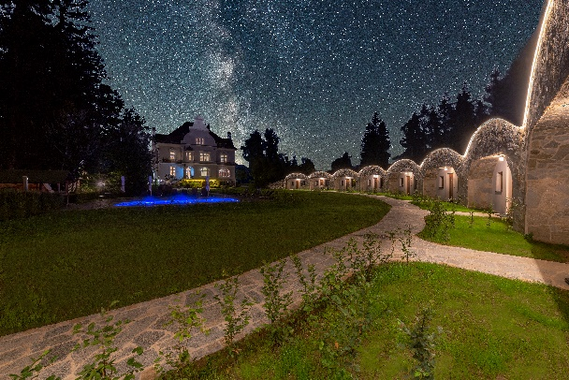
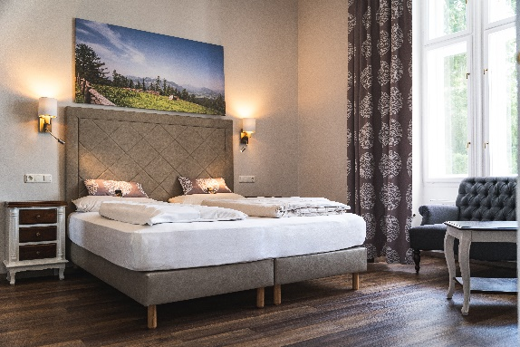 | 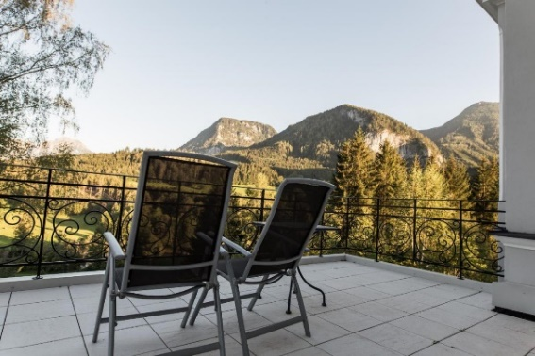
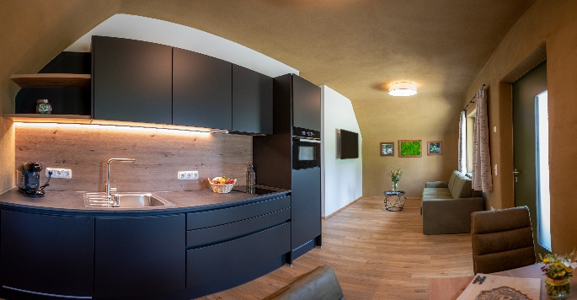 | 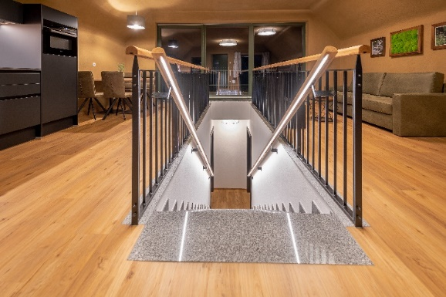
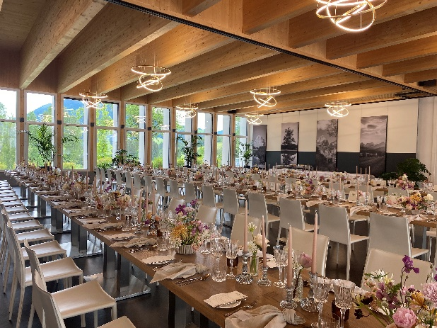 | 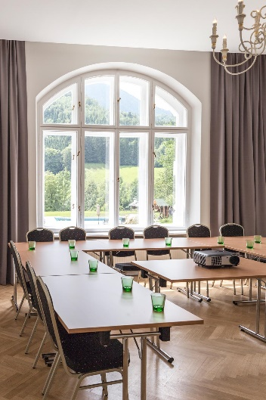

Terms and Conditions:

All information given is based on data that has been disclosed to us by the owner. Austria Real GmbH cannot therefore guarantee the accuracy of this information. This offer is only intended for the recipient, is to be treated confidentially and may not be made available to third parties. If a contract is concluded as a result of unauthorized disclosure, you are obliged to pay us compensation in the amount of the commission that would have been incurred in the event of success. Of course, the obligation to pay commission only arises when the legal transaction brokered by us comes about. We would like to point out that in the event of the purchase of the property listed above, you will have to reckon with the following additional costs in Austria:

- 3.5% real estate transfer tax
- 1.1% registration fee
- approx.* 1,5 % for the establishment, fiduciary execution and land registry processing of the purchase contract plus VAT (guideline value*, to be negotiated with a lawyer)
- 3% agency commission plus VAT to Austria Real GmbH

Contact
Tatjana Sulzenbacher
Hotel broker

T + 43 1 2632 555
F + 43 1 2632 555 10
M +43 644 5290774
ts@austriareal.com
www.austriareal.com

